***INTRODUCTION***

**CHAPTER 1**

**INTRODUCTION**

* 1. **PURPOSE OF PROJECT**

The ultimate goal is to help pet owners keep their furry friends healthy, happy, and well-groomed, ensuring that they enjoy a long and happy life together. In addition they need to keep their pets looking and feeling their best, an animal grooming website can also help pet owners build a stronger bond with their pets, increase their understanding of their pets' needs, and ensure their pets receive the best possible care.

**1.2 SYSTEM OVERVIEW**

This website helps in booking the grooming schedule without any complication or any hustle, moreover it provides door step service with well-experienced groomers with quality products.

**1.3 PROBLEM STATEMENT**

Many pet owners struggle to properly care for their pets' physical appearance and health, leading to health problems and a decreased quality of life for the pet.Pet owners often rely on their veterinarians for advice on animal grooming, but this can be time-consuming and expensive, and veterinarians may not always have the time to provide in-depth advice on grooming-related topics. In addition, pet owners may not have access to pet grooming experts or facilities in their area, making it difficult to get the help they need.The animal grooming website will provide pet owners with a one-stop-shop for all their animal grooming needs, making it easier for pet owners to properly care for their pets and keep them healthy and happy.

***REQUIREMENT***

**CHAPTER 2**

**REQUIREMENT SPECIFICATION**

* 1. **HARDWARE REQUIREMENTS & SOFTWARE REQUIREMENTS**
* **IDE**: visual studio code
* **Platform**: windows
  1. **CONSTRAINTS**
* SOFTWARE CONSTRAINTS:

The system will run under windows 7 or above.

* 1. **ASSUMPTIONS**
* The user will be able to access the website by themselves.
* All data received from the user via input is stored in the server.
* Proper verification for user details cannot be done with this project being a front-end-based one.

***DESIGN***

**CHAPTER 3**

**DESIGN**

Landing page

Leads to

* Home page
* Login page
* Register page
* Booking page
* Contact us page

Register page

* For users who don’t have an existing account.
* Receives user’s input.
* Stores them.
* Creates an account for them.

Login page

* For users having an account already.
* Receives users’ info.
* Verifies data.
* Allows them to proceed

Home page

* Short description
* Leads to booking page

Booking page

* Displays all available treatment
* Allows users to choose what they want to book.
* So later they can book the slot

Contact us page

* Users can give their feedback
* Users can also send their difficulties or bug ,so that we can resolve it.

***TESTING***

**CHAPTER 4**

**TESTING**

**4.1**   **UNIT TESTING**

Every unit on the webpage has been carefully assigned and curated to maximize the quality of output. Each part of the website was tested individually for independent performance analysis

**4.2**   **INTEGRATION TESTING**

The integration of all the parts of the webpage ultimately leads to the landing page. Placements of buttons, tabs, and other features were specifically tested. It was made sure that the pages preserved their original positioning all through the testing process.

**4.3**   **USER ACCEPTANCE TESTING**

The signup and login pages were efficiently tested to make sure that the user details were constantly updated and the previous data was stored as history.

**4.4**   **TEST REPORT**

System testing is very imminent in implementing the working of a website. Every detail of the page has gone through multiple testing to finally reveal its maximum potential. The design testing, placements and errors were checked and improved if any and the corrected end product is made available to the user.

***CODING***

**CHAPTER 5**

**CODING**

**5.1 LANDING PAGE -HTML**

<!DOCTYPE html>

<html lang="en">

<head>

<style>

img{

border-radius: 50%;

}

</style>

<meta charset="UTF-8">

<meta http-equiv="X-UA-Compatible" content="IE=edge">

<meta name="viewport" content="width=device-width, initial-scale=1.0">

<title>feline</title>

<link rel="stylesheet" type="text/css" href="style.css">

<link rel="preconnect" href="https://fonts.gstatic.com">

<link href="https://fonts.googleapis.com/css2?family=Josefin+Sans:ital,wght@0,100;0,300;0,400;0,500;0,600;0,700;1,100;1,300;1,300;1,400;1,500;1,600;1,700&family=Montserrat:wght@700;800;900&display=swap" rel="stylesheet">

</head>

<body>

<div class="hero">

<nav>

<nav class="navbar navbar-light bg-light">

<div class="container-fluid">

<a class="navbar-brand" href="#">

<img src="logo1.png" alt="" width="150" height="154" class="d-inline-block align-text-top">

</a>

</div>

</nav>

<h2 class="logo;" style="color: white;"><b>FELINE <span>SPA</span></b></h2>

<ul>

<li><a href='file:///D:/project/home.html'>HOME</a></li>

<!--<li><a href='#'>TOY AND ACCESSORIES</a></li>-->

<li><a href='#'></a></li>

<li><a href='file:///D:/project/book.html'>BOOKINGS</a></li>

<li><a href='file:///D:/project/contact_us.html'>CONTACT US</a></li>

</ul>

<button type="button"><a href="file:///D:/project/login.html#">LOGIN / REGISTER</a></button>

</nav>

<div class="text">

<h1 style="color: white;">Your Cat Deserves The Best !!!</h1><br><br><br><br>

</div>

<div class="quote">

<h1 style="background-color:rgba(0,0,0,0.4);color: white;">The People Who say "it's just a cat" Do Not Understand!!</h1>

</div>

</div>

</body>

</html>

**5.2 LANDING PAGE-CSS**

*{

padding:0;

margin:0;

box-sizing:border-box;

font-family: 'fantasy',papyrus;

}

.hero{

height:100vh;

width:100%;

background-image: linear-gradient(rgba(0,0,0,0.6),rgba(0,0,0,0.6)),url(background.jpg);

background-size:cover;

background-position: center;

}

nav{

display: flex;

align-items: center;

justify-content: space-between;

padding-top: 2px;

padding-left: 3%;

padding-right: 3%;

}

.logo{

color:white;

font-size:30px;

font-family: 'fantasy',papyrus;

}

span{

color:#ea1538;

}

nav ul li{

list-style-type: none;

display: inline-block;

padding:10px 20px;

}

nav ul li a{

color:white;

text-decoration: none;

font-weight:bold;

}

nav ul li a:hover{

color:#ea1538;

transition:.3s;

}

nav ul li.active a{

color: #ea1538;

}

button{

border:none;

background: #ea1538;

padding:12px 30px;

border-radius: 30px;

color:white;

font-weight: bold;

font-size: 15px;

transition: .4s;

}

button:hover{

transform: scale(1.3);

cursor: pointer;

}

.text{

font-size: 25px;

text-align: center;

}

.quote{

font-size: 20px;

text-align: center;

}

**5.3 LOGIN PAGE-HTML**

<!DOCTYPE html>

<html lang="en">

<head>

<meta charset="UTF-8">

<meta http-equiv="X-UA-Compatible" content="IE=edge">

<meta name="viewport" content="width=device-width, initial-scale=1.0">

<title>LOGIN</title>

<link rel="stylesheet" href="login.css">

</head>

<body>

<section>

<div class="form-box">

<div class="form-value">

<form action="">

<h2>LOGIN</h2>

<div class="inputbox">

<ion-icon name="mail-open-outline"></ion-icon>

<input type="email" required>

<label for=""><b>Email</b></label>

</div>

<div class="inputbox">

<ion-icon name="lock-closed-outline"></ion-icon>

<input type="password" required>

<label for=""><b>Password</b></label>

</div>

<div class="forget">

<label for=""><input type="checkbox">Remember Me</label>

<!--<a href="#"><b>Forget Password</b></a>-->

</div>

<button><a href="file:///D:/project/home.html">LOG IN</a></button>

<div class="register">

<p>Don't have a account?<a href="file:///D:/project/register.html"><b>Register</b></a></p>

</div>

</form>

</div>

</div>

</section>

<script type="module" src="https://unpkg.com/ionicons@5.5.2/dist/ionicons/ionicons.esm.js"></script>

<script nomodule src="https://unpkg.com/ionicons@5.5.2/dist/ionicons/ionicons.js"></script>

</body>

</html>

**5.4 LOGIN PAGE-CSS**

*{

margin: 0;

padding: 0;

font-family: 'fantasy',papyrus;

}

section{

display: flex;

justify-content: center;

align-items: center;

min-height: 100vh;

width:100%;

background: url('login1.jpg')no-repeat;

background-position: center;

background-size: cover;

}

.form-box{

position: relative;

width: 400px;

height: 450px;

background: transparent;

display: flex;

justify-content: center;

align-items: center;

}

h2{

font-size: 2em;

color: white;

text-align: center;

}

.inputbox{

position: relative;

margin: 30px 0;

width: 310px;

border-bottom: 2px solid white;

}

.inputbox label{

position: absolute;

top: 50%;

left: 5px;

transform: translateY(-50%);

color: white;

font-size: 1em;

pointer-events: none;

transition: .5s;

}

input:focus ~ label,

input:valid ~ label{

top:-5px;

}

.inputbox input {

width: 100%;

height: 50px;

background: transparent;

border: none;

outline: none;

font-size: 1em;

padding:0 35px 0 5px;

color: white;

}

.inputbox ion-icon{

position: absolute;

right: 8px;

color: white;

font-size: 1.2em;

top: 20px;

}

.forget{

margin: -15px 0 15px;

font-size: .9em;

color: white;

display: flex;

justify-content: center;

}

.forget label input{

margin-right: 3px;

}

.forget label a{

color: white ;

text-decoration: none;

}

.forget label a:hover{

text-decoration: underline;

}

button{

width:100%;

height: 40px;

border-radius: 40px;

background: #fff;

border: none;

outline: none;

cursor: pointer;

font-size: 1em;

font-weight: 600;

}

.register{

font-size: .9em;

color: white;

text-align: center;

margin: 25px 0 10px;

}

.register p a{

text-decoration: none;

color: white;

font-weight: 600;

}

.register p a:hover{

text-decoration: underline;}

**5.5 REGISTER PAGE-HTML**

<!DOCTYPE html>

<html lang="en">

<head>

<meta charset="UTF-8">

<meta http-equiv="X-UA-Compatible" content="IE=edge">

<meta name="viewport" content="width=device-width, initial-scale=1.0">

<title>REGISTER</title>

<link rel="stylesheet" href="login.css">

</head>

<body>

<section>

<div class="form-box">

<div class="form-value">

<form action="">

<h2>REGISTER</h2>

<div class="inputbox">

<ion-icon name="person-outline"></ion-icon>

<input type="name" required>

<label for=""><b>Name</b></label>

</div>

<div class="inputbox">

<ion-icon name="mail-open-outline"></ion-icon>

<input type="email" required>

<label for=""><b>Email</b></label>

</div>

<div class="inputbox">

<ion-icon name="lock-closed-outline"></ion-icon>

<input type="password" required>

<label for=""><b>Password</b></label>

</div>

<div class="inputbox">

<ion-icon name="call-outline"></ion-icon>

<input type="number" required>

<label for=""><b>Phone number</b></label>

</div>

<button><b>

<a href="file:///D:/project/home.html">LOG IN</a></b></button>

</form>

</div>

</div>

</section>

<script

type="module" src="https://unpkg.com/ionicons@5.5.2/dist/ionicons/ionicons.esm.js">

</script>

<script

nomodule src="https://unpkg.com/ionicons@5.5.2/dist/ionicons/ionicons.js"></script>

</body>

</html>

**5.6 HOME PAGE-HTML**

<!DOCTYPE html>

<html>

<head>

<title>home page</title>

<style>

body {

background-color: #f2f2f2;

text-align: center;

background-image: linear-gradient(rgba(0,0,0,0.6),rgba(0,0,0,0.6)),url(home1.jpg);

background-size:cover;

background-position: center;

color:white;

font-family: 'fantasy',papyrus;

padding: 25px;

}

main {

padding: 20px;

font-family: 'fantasy',papyrus;

font-size: 1em;

}

h1 {

font-size: 36px;

}

.btn {

background-color: #4CAF50;

color: white;

padding: 15px 20px;

border-radius: 5px;

text-decoration: none;

margin-top: 20px;

display: inline-block;

}

img{

border-radius: 50%;

}

</style>

</head>

<body>

<img src="logo1.png" alt="" width="150" height="154" class="d-inline-block align-text-top">

<h1 style="font-size: 40px;">!!..FELINE SPA ..!!</h1>

<h2>A Cat paradise</h2>

<h2><i>Cat Grooming serice - Just one click ahead!!!!</i></h2>

<main>

<h1 style="color: rgb(192, 95, 95);">Cat Grooming service that comes to your home</h1>

<h2>Instantly book a professional cat groomer online ,whenever you need one.</h2>

<a href="file:///D:/project/book.html" class="btn">BOOK NOW</a>

</main>

</body>

</html>

**5.7 BOOKING PAGE-HTML**

<!DOCTYPE html>

<html>

<head>

<title>BOOK</title>

<link href="https://fonts.googleapis.com/css2?family=Poppins:wght@400;600&display=swap" rel="stylesheet">

<link rel="stylesheet" href="book.css">

</head>

<body>

<div class="cards">

<div class="card card1">

<div class="container">

<img src="https://d.newsweek.com/en/full/1747048/cat.jpg?w=790&f=f48865239245ac6ddc88dac97d02d52d" >

</div>

<div class="details">

<h3>Bath+Basic grooming--INR 800</h3>

<p>Bath with shampoo and conditioner,blow dry,nail clipping,ear cleaning,eye cleaning,paw masssage,combing/brushing,sanitary trim,face haircutting</p>

<a href="file:///D:/project/booked.html" class="btn" style="background-color: whitesmoke; border: dotted;">Book a groomer</a>

</div>

</div>

<div class="card card2">

<div class="container">

<img src="https://img.freepik.com/premium-photo/cat-sleeping-massage-table-while-taking-spa-treatments-massage-oil-relax_458466-130.jpg?w=2000">

</div>

<div class="details">

<h3>Full service--INR 1499</h3>

<p>Bath with shampoo,conditioner,blow dry,full body trimming,body massage,sanitary trim,nail clipping,ear cleaning,nail cleaning,eye cleaning,paw massage,combing/brushing</p>

<a href="file:///D:/project/booked.html" class="btn" style="background-color: whitesmoke; border: dotted;">Book a groomer</a>

</div>

</div>

<div class="card card3">

<div class="container">

<img src="https://media.istockphoto.com/id/1309813017/photo/spa-and-wellness-composition-with-aromatic-rose-water-salt-archidea-flowers-and-a-sleeping.jpg?s=612x612&w=0&k=20&c=ho-OY7URQGJmPRp6pFYUi045diwKhu2daz16AVUSmMM=" >

</div>

<div class="details">

<h3>Trans-fur-mation--INR 1199</h3>

<p>Full body trimming ,ear cleaning,eyes cleaning,nail clipping</p>

<a href="file:///D:/project/booked.html" class="btn" style="background-color: whitesmoke; border: dotted; color: black;">Book a groomer</a>

</div>

</div>

</div>

</body>

</html>

**5.8 BOOKING PAGE-CSS**

*{

padding: 0;

margin: 0;

box-sizing: border-box;

}

body{

height: 100vh;

display: grid;

place-items: center center;

font-family: 'fantasy',papyrus;

background-image: linear-gradient(rgba(0,0,0,0.6),rgba(0,0,0,0.6)),url(background.jpg);

background-size:cover;

background-position: center;

}

.cards{

display: grid;

grid-template-columns: repeat(auto-fit,minmax(400px,1fr));

padding: 20px;

grid-gap: 40px;

}

.card{

background-color: #1c1b29;

border-radius: 20px;

box-shadow: 0 0 30px rgba(0,0,0,0.18);

}

.container{

position: relative;

clip-path: polygon(0 0,100% 0, 100% 85%, 0 100%);

}

img{

width: 100%;

display: block;

border-radius: 20px 20px 0 0;

}

.container:after{

content: "";

height: 100%;

width: 100%;

position: absolute;

top: 0;

left: 0;

border-radius: 20px 20px 0 0;

opacity: 0.7;

}

.details{

padding: 20px 30px;

}

.details>h3{

color: #ffffff;

font-weight: 600;

font-size: 28px;

margin: 10px 0 15px 0;

}

.details>p{

color: #a0a0a0;

font-size: 15px;

line-height: 30px;

font-weight: 400;

font-size: 18px;

}

**5.9 SUBMISSION PAGE-HTML**

<!DOCTYPE html>

<html>

<head>

<title>booked</title>

<style>

body {

font-family: Arial, sans-serif;

background-color: white;

text-align: center;

background-image:

linear-gradient(rgba(0,0,0,0.6),rgba(0,0,0,0.6)),url(booked.jpg);

background-size:cover;

background-position: center;

color:white;

font-family: 'fantasy',papyrus;

padding: 1px;

}

main {

padding: 20px;

font-family: 'fantasy',papyrus;

font-size: 1em;

}

h1 {

font-size: 36px;

}

.btn {

background-color: #4CAF50;

color: white;

padding: 15px 20px;

border-radius: 5px;

text-decoration: none;

margin-top: 20px;

display: inline-block;

}

img{

border-radius: 50%;

}

</style>

</head>

<body>

<script type="text/javascript">

window.alert("Your session has been booked successfully");

</script>

<img src="logo1.png" alt="" width="150" height="154" class="d-inline-block align-text-top">

<h1 style="color:white; font-size: 45px;"><b>!!..FELINE SPA ..!!</b></h1>

<h2>A Cat paradise</h2>

<h2 style="font-size: 40px;color: rgb(192, 95, 95)"><i>!....Your Booking Is Successful....!</i></h2>

<main>

<h1>Cash will be collected after the grooming session , You can pay directly through cash or through online transaction</h1>

<h2><i>Your cat will love the new look and renewness..!!!!!!</i></h2>

<a href="file:///D:/project/contact_us.html" class="btn">CONTINUE</a>

</main>

</body>

</html>

**5.10 CONTACT US PAGE-HTML**

<!DOCTYPE html>

<html lang="en">

<head>

<meta charset="UTF-8">

<meta http-equiv="X-UA-Compatible" content="IE=edge">

<meta name="viewport" content="width=device-width, initial-scale=1.0">

<title>Contact Us</title>

<link rel="stylesheet" href="contact_us.css">

</head>

<body>

<div class="container">

<form>

<h1><b>Contact Us</b> </h1>

<input type="text" id="firstName" placeholder="First Name" required>

<input type="text" id="lastName" placeholder="Last Name" required>

<input type="email" id="email" placeholder="Email" required>

<input type="text" id="mobile" placeholder="Mobile" required>

<h4>Type Your Message Here...</h4>

<textarea required></textarea>

<input type="submit" value="Send" id="button">

</form>

</div>

</body>

</html>

**5.11 CONTACT US PAGE-CSS**

@import url('https://fonts.googleapis.com/css2?family=Poppins:wght@100;200;300;400;500;600;700;800;900&display=swap');

*{

margin: 0;

padding: 0;

box-sizing: border-box;

font-family: 'fantasy',papyrus;

}

.container{

min-height: 100vh;

background: #08071d;

display: flex;

justify-content: center;

align-items: center;

background: url("login.jpg") no-repeat center center/cover;

}

.container form{

width: 670px;

height: 400px;

display: flex;

justify-content: center;

box-shadow: 20px 20px 50px rgba(0,0,0,0.5);

border-radius: 15px;

background: rgba(255,255,255,0.1);

backdrop-filter: blur(10px);

flex-wrap: wrap;

}

.container form h1{

color: black;

font-weight: 500;

margin-top: 20px;

width: 500px;

text-align: center;

}

.container form input{

width: 290px;

height: 40px;

padding-left: 10px;

outline: none;

border: none;

font-size: 15px;

margin-bottom: 10px;

background: none;

border-bottom: 2px solid black;

}

.container form input::placeholder{

color: black;

}

.container form #lastName,

.container form #mobile{

margin-left: 20px;

}

.container form h4{

color: black;

font-weight: 300;

width: 600px;

margin-top: 20px;

}

.container form textarea{

background: none;

border: none;

border-bottom: 2px solid black;

color: black;

font-weight: 200;

font-size: 15px;

padding: 10px;

outline: none;

min-width: 600px;

max-width: 600px;

min-height: 80px;

max-height: 80px;

}

textarea::-webkit-scrollbar{

width: 1em;

}

textarea::-webkit-scrollbar-thumb{

background-color: rgba(194,194,194,0.713);

}

.container form #button{

border: none;

background: white;

border-radius: 5px;

margin-top: 20px;

font-weight: 600;

font-size: 20px;

color: #333;

width: 100px;

padding: 0;

margin-right: 500px;

margin-bottom: 30px;

transition: 0.3s;

}

.container form #button:hover{

opacity: 0.7;

}

***OUTPUTS***

***OUTPUT***

**CHAPTER 6**

**OUTPUTS**

**6.1 LANDING PAGE**

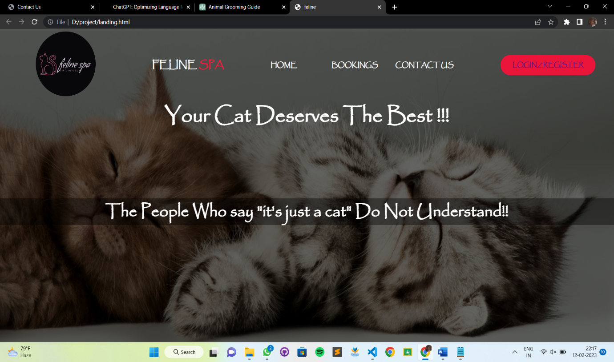

**6.2 LOGIN PAGE**

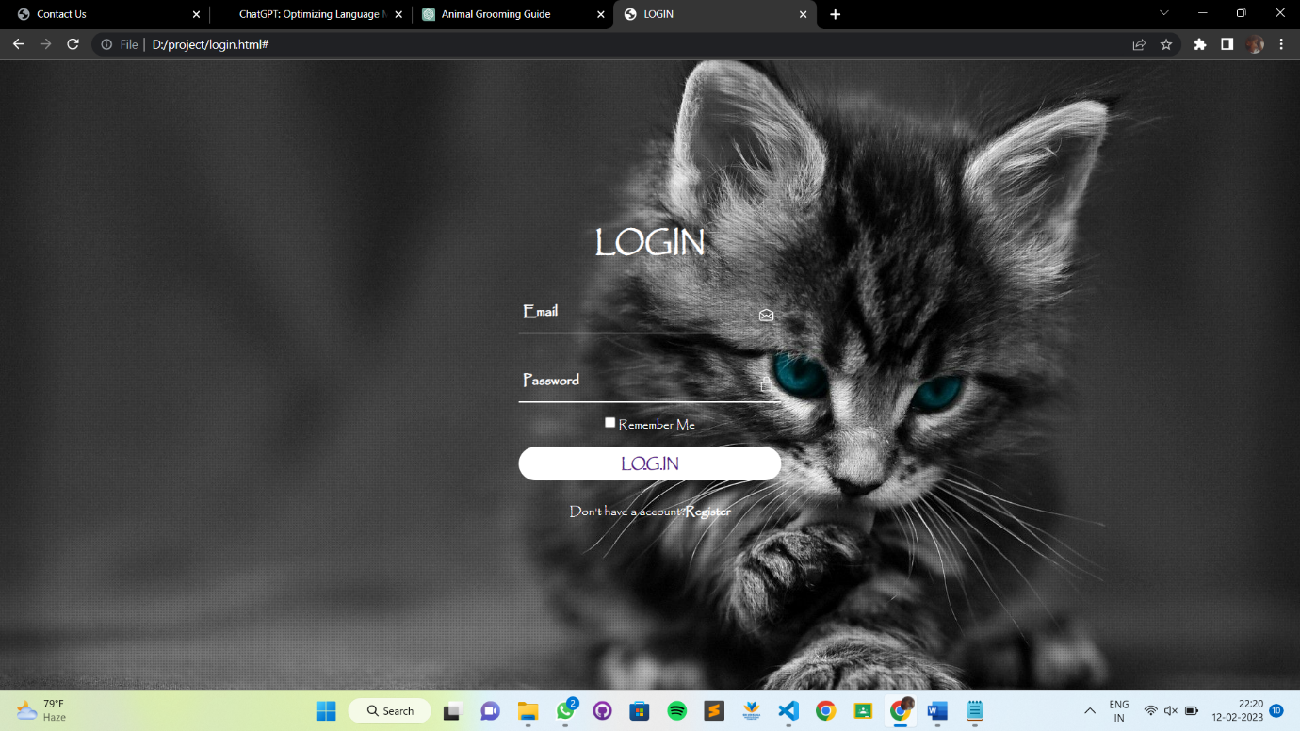

**6.3 REGISTER PAGE**

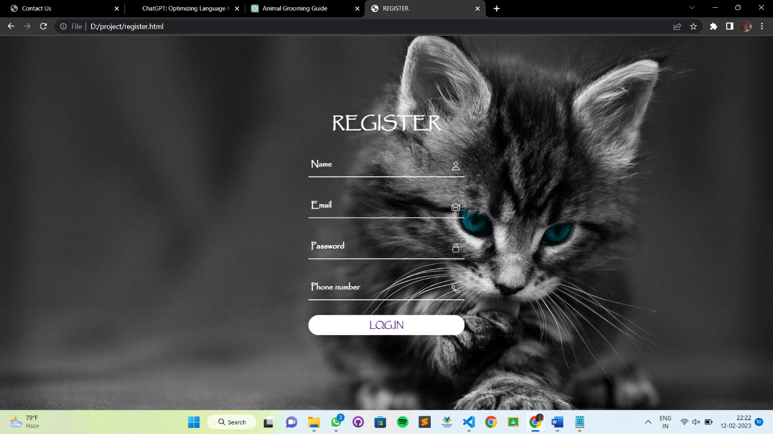

**6.4 HOME PAGE**

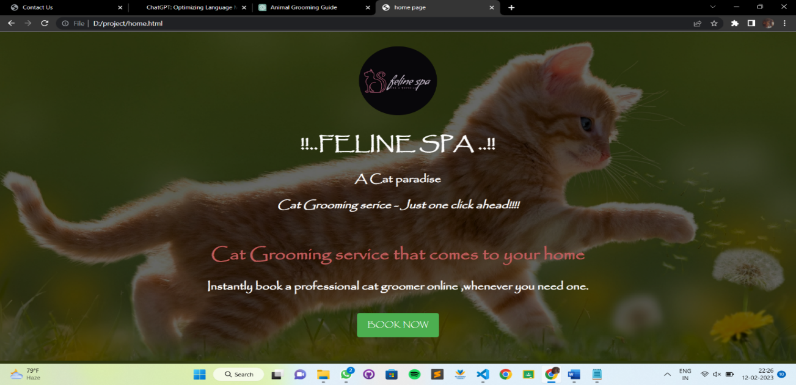

**6.5 BOOKING PAGE**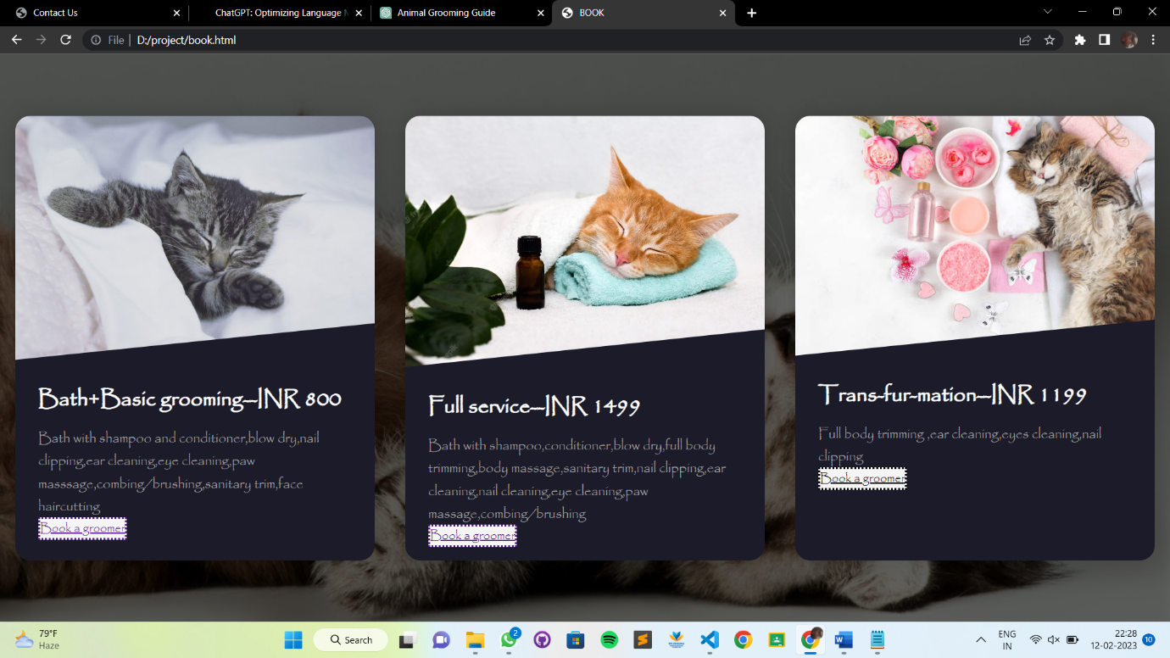

**6.5.1 DETAIL PAGE**

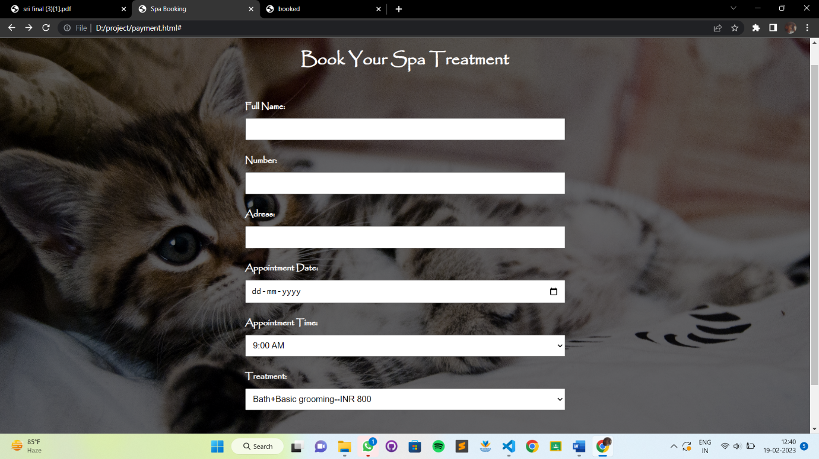

**6.6 REASSURANCE PAGE**

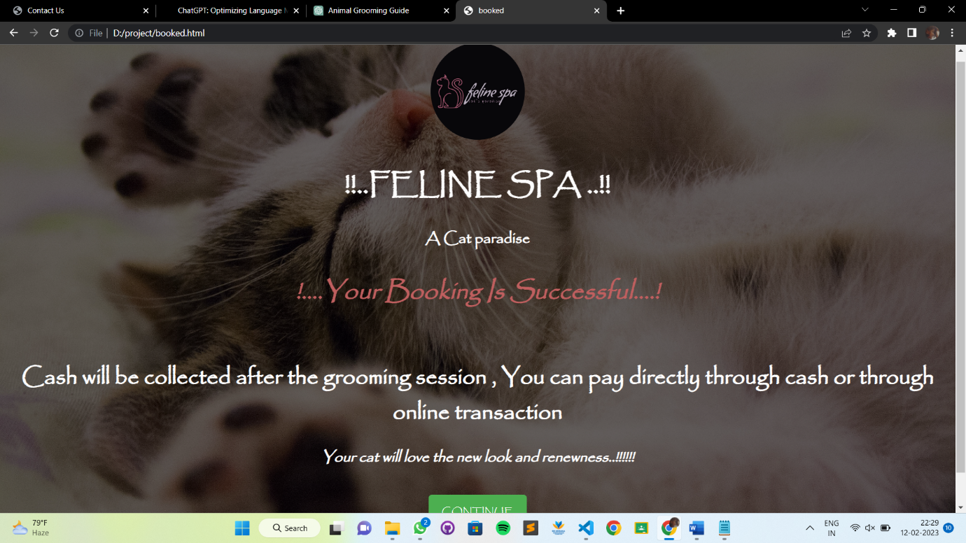

**6.7 CONTACT US PAGE**

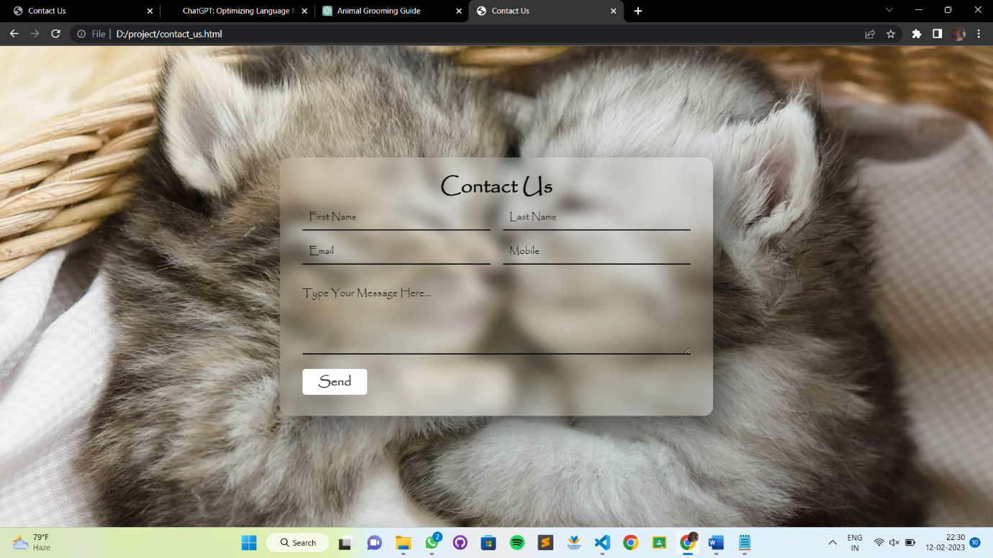

***FUTURE ENHAMCEMENT***

**CHAPTER 7**

**FUTURE ENHANCEMENTS**

There are several future enhancements that could be made to the animal grooming website to further improve the user experience and provide even more comprehensive resources for pet owners:

Virtual Grooming Assistance: A feature that allows pet owners to connect with professional groomers in real-time, who can provide personalized advice and guidance on grooming their pets.

Online Grooming Appointments: A feature that allows pet owners to schedule grooming appointments with professional groomers in their area directly from the website, eliminating the need for phone calls or in-person visits.

Personalized Grooming Plans: A feature that creates a customized grooming plan for each pet based on their breed, age, and health status, providing pet owners with a tailored approach to their pet's grooming needs.

Interactive Grooming Tools: A set of interactive tools that help pet owners determine the best grooming techniques and products for their pets, including a skin and coat type selector and a product recommendation tool.

Mobile App: A mobile app that provides pet owners with quick and easy access to all the resources and features of the animal grooming website, including step-by-step guides, health resources, product recommendations, and community forums.

By continuously improving the animal grooming website and adding new features and resources, the platform will continue to be an essential tool for pet owners everywhere, providing them with the information and resources they need to properly care for their pets and keep them healthy and happy.

***CONCLUSION***

**CHAPTER 8**

**CONCLUSION**

In conclusion, the animal grooming website is a valuable resource for pet owners everywhere. By providing comprehensive information and resources on animal grooming, the website aims to help pet owners properly care for their pets' physical appearance and health, leading to happier, healthier pets and stronger bonds between pets and their owners. will be a valuable resource for pet owners for years to come.

***REFERENCES***

**CHAPTER 9**

**REFERENCES**

* <https://www.w3schools.com/>
* https://cfa.org/cat-owner-resources/grooming-your-cat/
* PetMD - https://www.petmd.com/cat/grooming PetMD is a comprehensive resource for pet health and wellness. Their grooming section provides articles and videos on grooming tips for cats, including bathing, brushing, nail trimming, and ear cleaning.
* YouTube videos